**ANNEXURE 1**

**Awareness Program Report on Establishment of Analog and Digital Network Using Amateur Radio Communication**

**Project Title:** Establishment of Analog and Digital Network Using Amateur Radio Communication Between Schools and Colleges

**Organized by:** Department of Electronics and Communication Engineering, Vasavi College of Engineering In Association with Amateur Radio Digital Communications (ARDC)-USA

**Venue:** Vasavi Public School, Himayatnagar, Hyderabad

**Date: July 30th**

**The primary objectives of the awareness program were:**

* To educate students about the fundamentals of amateur radio communication.
* To encourage students to explore careers and hobbies in HAM Radio
* To foster collaboration and communication skills among students from different schools and colleges.

As part of the project implementation titled "Establishment of Analog and Digital Network Using Amateur Radio Communication Between Schools and Colleges," an awareness program was organized by Dr. Kishore, Associate professor and the Principal Investigator (PI). This event aimed to educate and engage students in the importance and functionality of amateur radio communications.

**Participants:**

* **Number of Students:** 250
  + **Classes:** 8, 9, and 10
* **School Representatives:**
  + **Vice Principal of Vasavi School**
  + **Teachers**

**Key Highlights of the Event:**

1. **Introduction to Amateur Radio:**
   * Dr. Kishore provided an in-depth explanation of amateur radio, its history, and its significance in modern communication networks.
   * Emphasis on the difference between analog and digital communication.
2. **Educational Content:**
   * Presentations on the basic principles of radio waves, frequency modulation, and the technical aspects of setting up amateur radio stations.
   * Discussion on the applications of amateur radio in emergency communication and community services.
3. **Interactive Sessions:**
   * Q&A session where students asked various questions about the technology and its applications.
   * Engaging activities to explain the concepts in a simple and interactive manner.
4. **Feedback and Participation:**
   * The Vice Principal and teachers actively participated in the event, providing valuable feedback and encouraging students to explore further in this field.
   * Students showed great enthusiasm and interest in amateur radio communications.

**Impact and Future Plans:**

The awareness program was successful in sparking curiosity and interest among the students. The school administration expressed their willingness to integrate amateur radio workshops as part of their extracurricular activities. Future plans include:

* Regular workshops and training sessions to deepen the students' understanding.
* Establishment of HAM Radio Station.
* Encouraging students to participate in amateur radio competitions and events.

blob:https://web.whatsapp.com/ca54d8ca-48aa-4b43-a880-76fd6948188e blob:https://web.whatsapp.com/ca54d8ca-48aa-4b43-a880-76fd6948188e blob:https://web.whatsapp.com/6579cff4-7df4-4a75-bc1b-bb99e85eae50 blob:https://web.whatsapp.com/6579cff4-7df4-4a75-bc1b-bb99e85eae50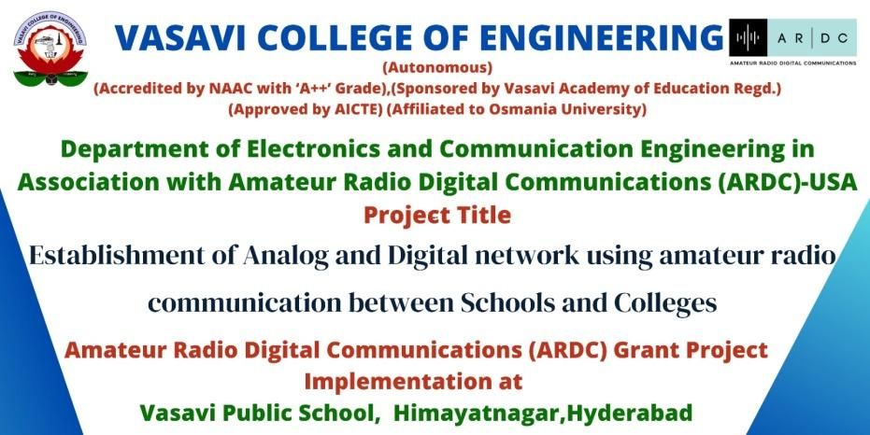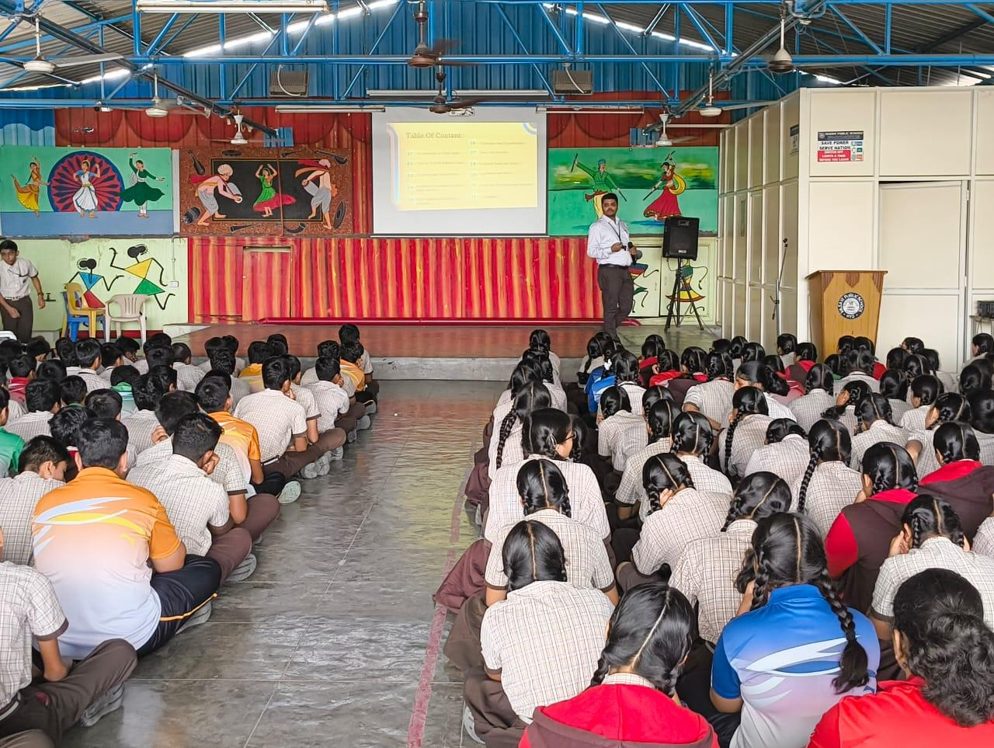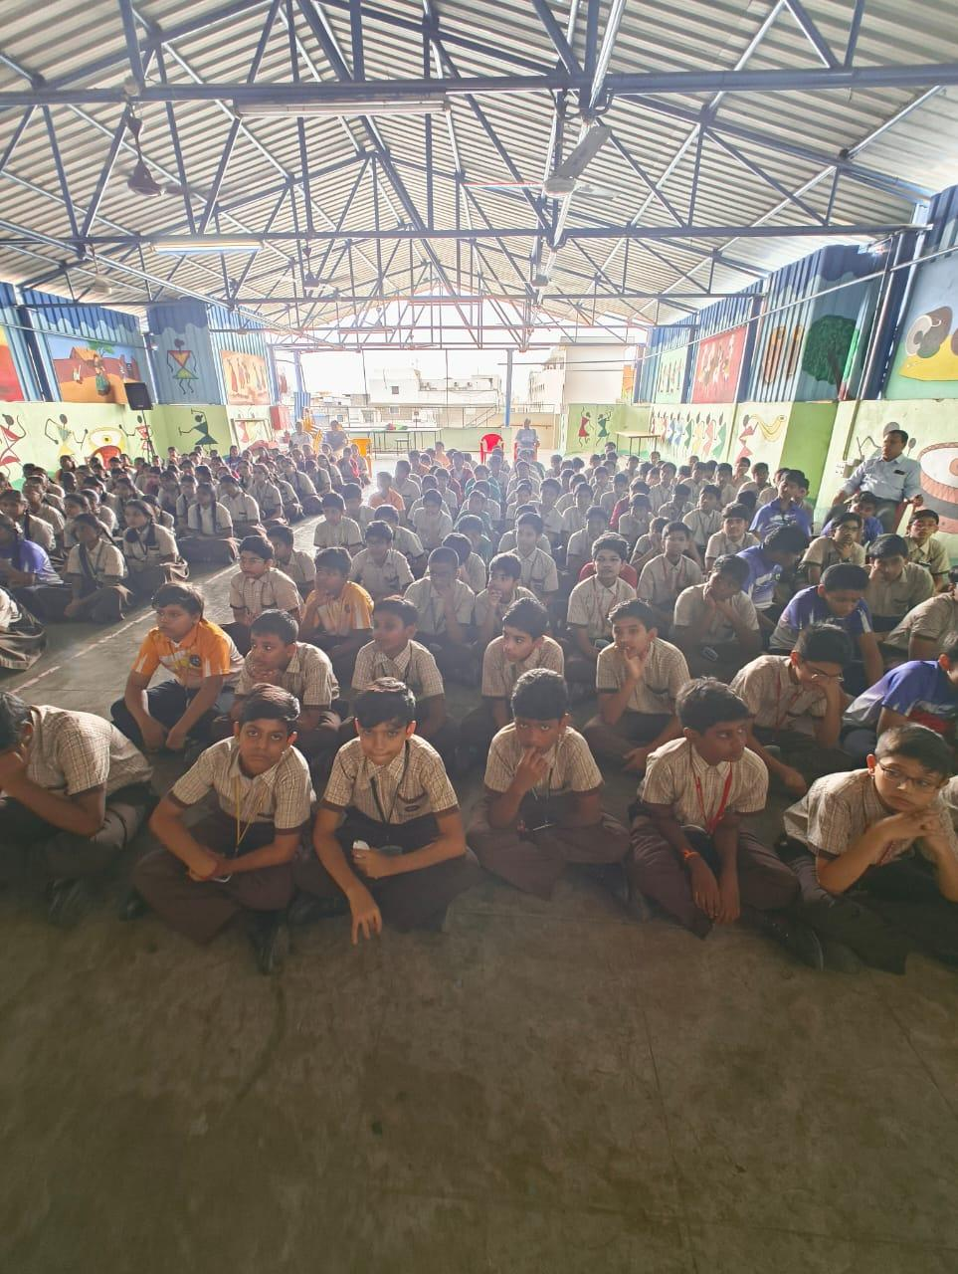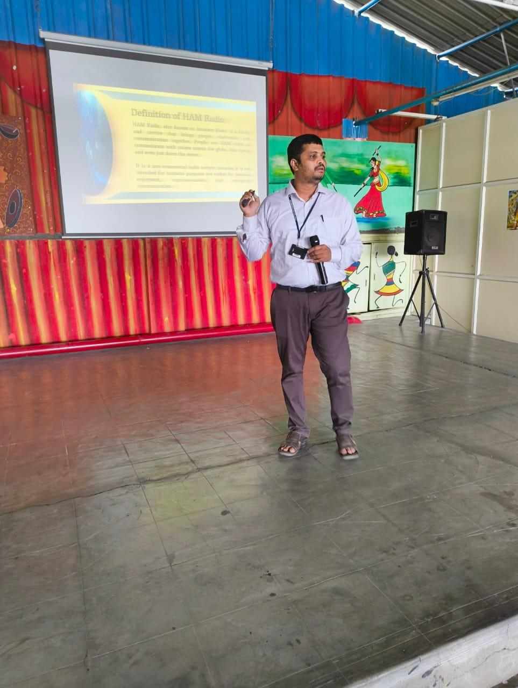

**ANNEXURE 2**

**Awareness Program Report on Establishment of Analog and Digital Network Using Amateur Radio Communication**

**Project Title:** Establishment of Analog and Digital Network Using Amateur Radio Communication Between Schools and Colleges

**Organized by:** Department of Electronics and Communication Engineering, Vasavi College of Engineering In Association with Amateur Radio Digital Communications (ARDC)-USA

**Venue:** Vasavi Polytechnic, Banaganapalle, Kurnool District,Andhra Pradesh

**Date: August 3rd**

**The primary objectives of the awareness program were:**

* To educate students about the fundamentals of amateur radio communication.
* To encourage students to explore careers and hobbies in HAM Radio
* To foster collaboration and communication skills among students from different schools and colleges.

As part of the project implementation titled "Establishment of Analog and Digital Network Using Amateur Radio Communication Between Schools and Colleges," an awareness program was organized by Dr. Kishore, Associate professor and the Principal Investigator (PI). This event aimed to educate and engage students in the importance and functionality of amateur radio communications.

**Participants:**

* **Number of Students:** 360
* **School Representatives:**
  + **Principal**
  + **Teachers**

**Key Highlights of the Event:**

1. **Introduction to Amateur Radio:**
   * Dr. Kishore provided an in-depth explanation of amateur radio, its history, and its significance in modern communication networks.
   * Emphasis on the difference between analog and digital communication.
2. **Educational Content:**
   * Presentations on the basic principles of radio waves, frequency modulation, and the technical aspects of setting up amateur radio stations.
   * Discussion on the applications of amateur radio in emergency communication and community services.
3. **Interactive Sessions:**
   * Q&A session where students asked various questions about the technology and its applications.
   * Engaging activities to explain the concepts in a simple and interactive manner.
4. **Feedback and Participation:**
   * The Principal and teachers actively participated in the event, providing valuable feedback and encouraging students to explore further in this field.
   * Students showed great enthusiasm and interest in amateur radio communications.

**Impact and Future Plans:**

The awareness program was successful in sparking curiosity and interest among the students. The school administration expressed their willingness to integrate amateur radio workshops as part of their extracurricular activities. Future plans include:

* Regular workshops and training sessions to deepen the students' understanding.
* Establishment of HAM Radio Station.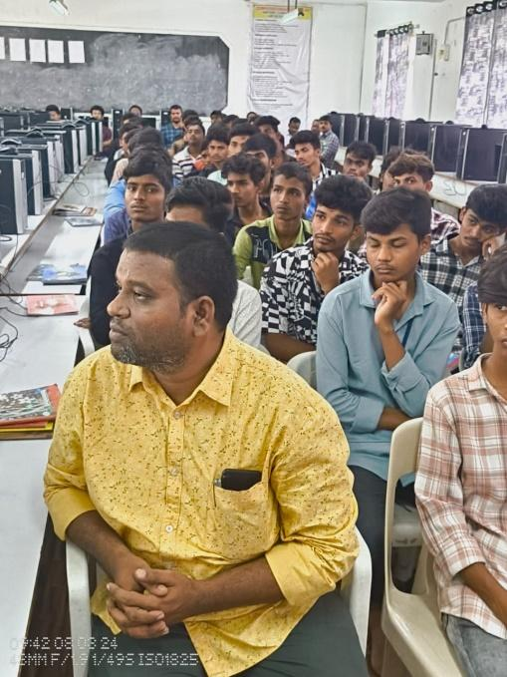
* Encouraging students to participate in amateur radio competitions and events.

blob:https://web.whatsapp.com/ca54d8ca-48aa-4b43-a880-76fd6948188eblob:https://web.whatsapp.com/ca54d8ca-48aa-4b43-a880-76fd6948188eblob:https://web.whatsapp.com/6579cff4-7df4-4a75-bc1b-bb99e85eae50blob:https://web.whatsapp.com/6579cff4-7df4-4a75-bc1b-bb99e85eae50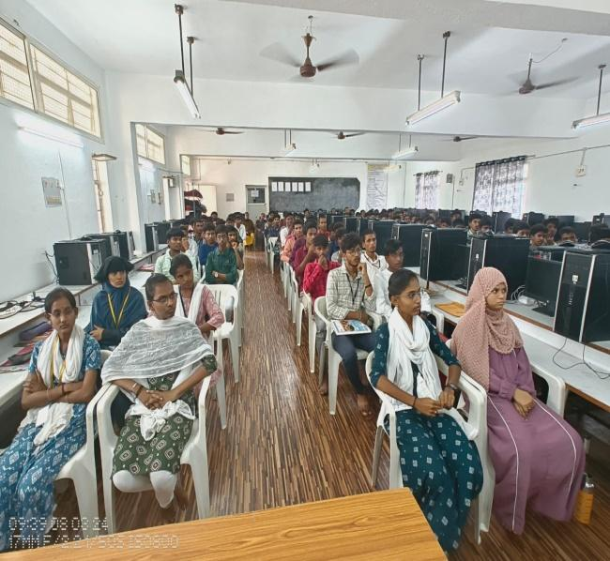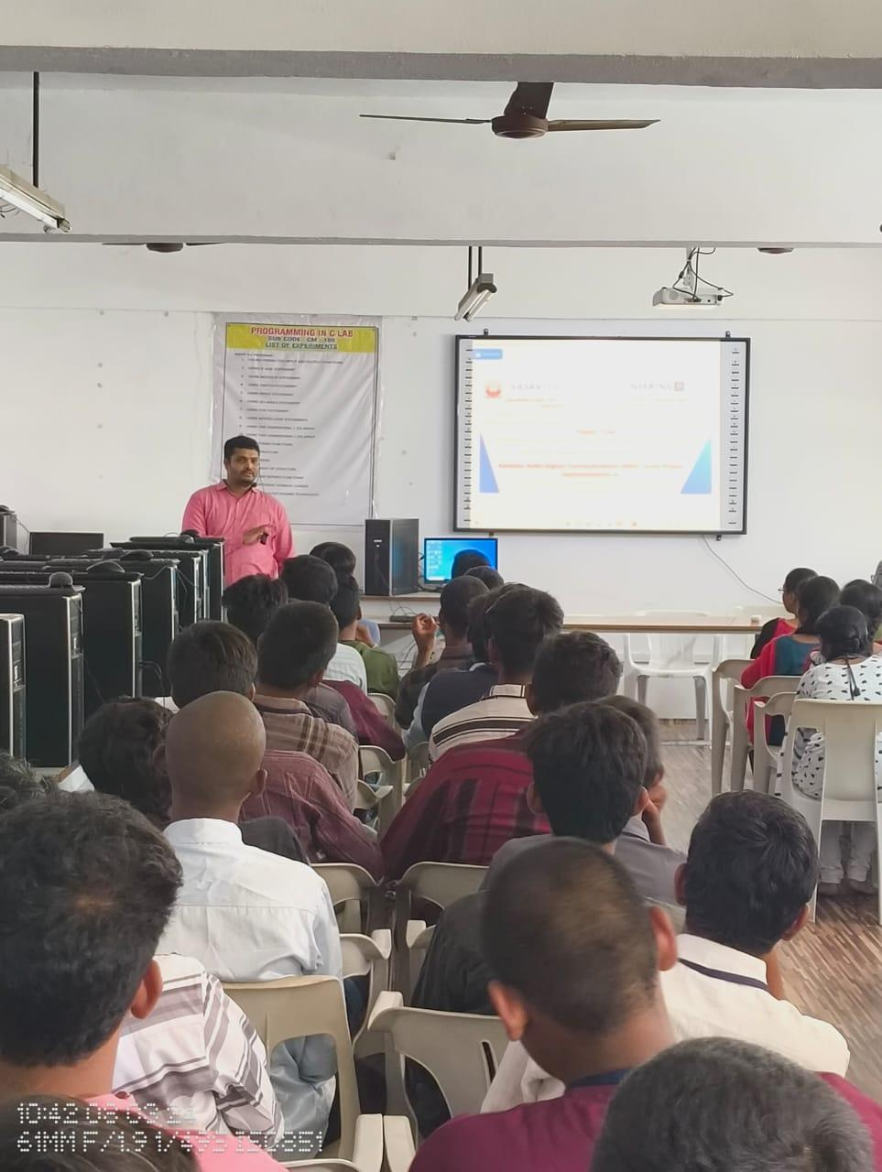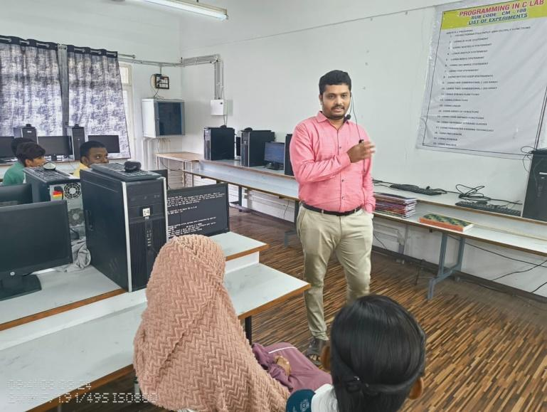

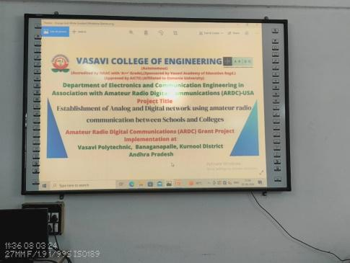

**ANNEXURE 3**

**Progress Report on Amateur Radio Skill Development and Infrastructure Implementation**

**Project Title:** Establishment of Analog and Digital Network Using Amateur Radio Communication and Research Labs

**Organized by:** Department of Electronics and Communication Engineering, Vasavi College of Engineering, in association with Amateur Radio Digital Communications (ARDC-USA)

**Introduction**

This report details the successful training programs and infrastructure initiatives conducted to enhance the skill set of students in amateur (HAM) radio communication. The efforts are aimed at equipping students with hands-on knowledge and experience in analog and digital communication technologies, supported by newly established Amateur Radio Research Labs.

**Training Overview**

In the initial phases of the program, we successfully trained a diverse group of students across various educational institutions:

* **31 students from Vasavi Public School**
* **110 students from Vasavi Polytechnic**
* **126 students from Vasavi College of Engineering**

The training sessions focused on the fundamentals of amateur radio communication, including the technical aspects of signal transmission, modulation techniques, and hands-on activities to ensure comprehensive learning.

**Infrastructure Development**

The first phase of equipment installation for the Amateur Radio Research Labs has been completed. Research labs were established at three key locations, outfitted with state-of-the-art equipment to support practical learning in radio communication. These labs will serve as dedicated spaces where students can explore the mechanics and applications of HAM radio technology under the guidance of qualified instructors.

**Establishment of Amateur Radio Research Labs**

In partnership with ARDC, we have set up Amateur Radio Research Labs at three separate facilities:

1. **Vasavi Public School**
2. **Vasavi Polytechnic**
3. **Vasavi College of Engineering**

These labs are equipped to provide students with hands-on experience in designing and operating amateur radio stations, offering a platform for research and experimentation in analog and digital communication.

**Licensing Examination for Amateur Radio Operators**

To further enhance the skill development and qualification of our students, we have applied for the **Amateur Station Operator's Certificate (ASOC) examination**. The first phase of this government-recognized license exam will be conducted in **November** by the Government of India. This certification will enable students to operate amateur radio stations legally and deepen their practical knowledge and experience in the field.

**Internship Program**

A **6-month internship program** has been launched for students at Vasavi Polytechnic. This program provides hands-on experience in the design, development, and testing of receivers and Software Defined Radio (SDR) systems. Interns will receive structured guidance in the principles of communication systems, modulation techniques, and system integration, fostering practical expertise and professional skills.

**Key Achievements**

* **Skill Development:** Students gained foundational knowledge in amateur radio communication, preparing them for future careers in the field.
* **Equipment Installation:** Completed the first phase of infrastructure setup for Amateur Radio Research Labs, making them fully operational.
* **Licensing Opportunity:** Students are prepared to sit for the ASOC exam in November, which will officially qualify them as licensed amateur radio operators.
* **Internship Program:** Launched a structured internship for Polytechnic students, aimed at enhancing design and technical skills with hands-on projects.

**Future Plans**

1. **Advanced Training Workshops:** We plan to conduct regular training sessions to deepen students' understanding and skills.
2. **Competitions and Events:** Students will be encouraged to participate in HAM radio competitions, promoting collaboration and innovation.
3. **Lab Expansion:** Plans are underway to expand lab capabilities, including advanced communication technologies and software tools.

This initiative marks a significant step towards building practical and theoretical expertise in amateur radio among students across different educational levels, helping them develop valuable technical skills for the future.

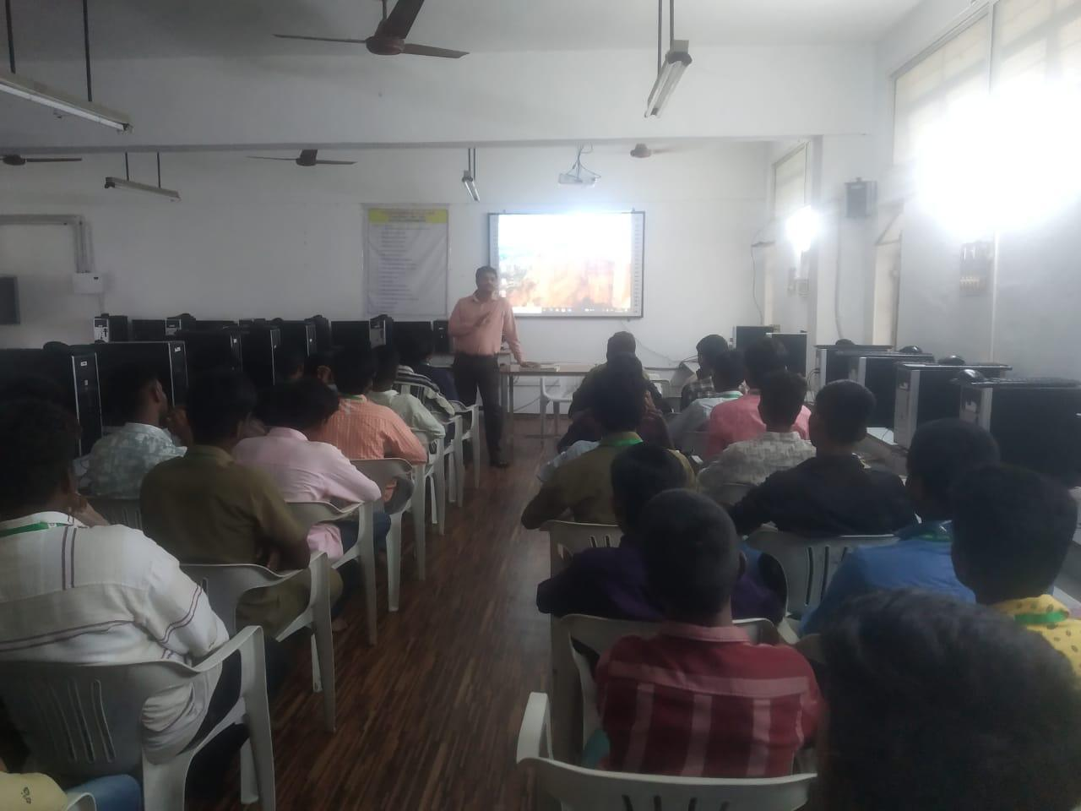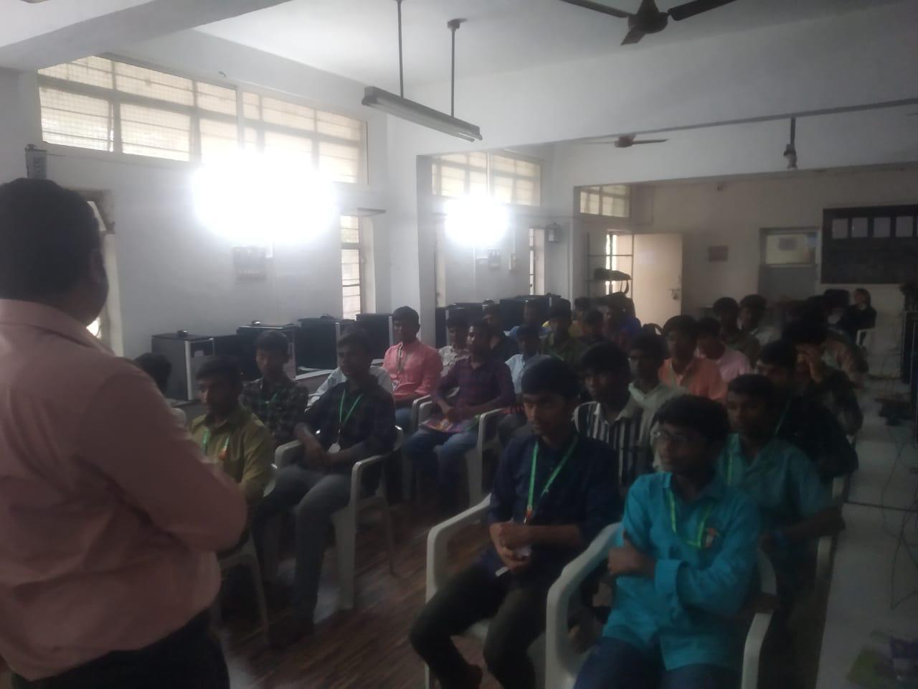

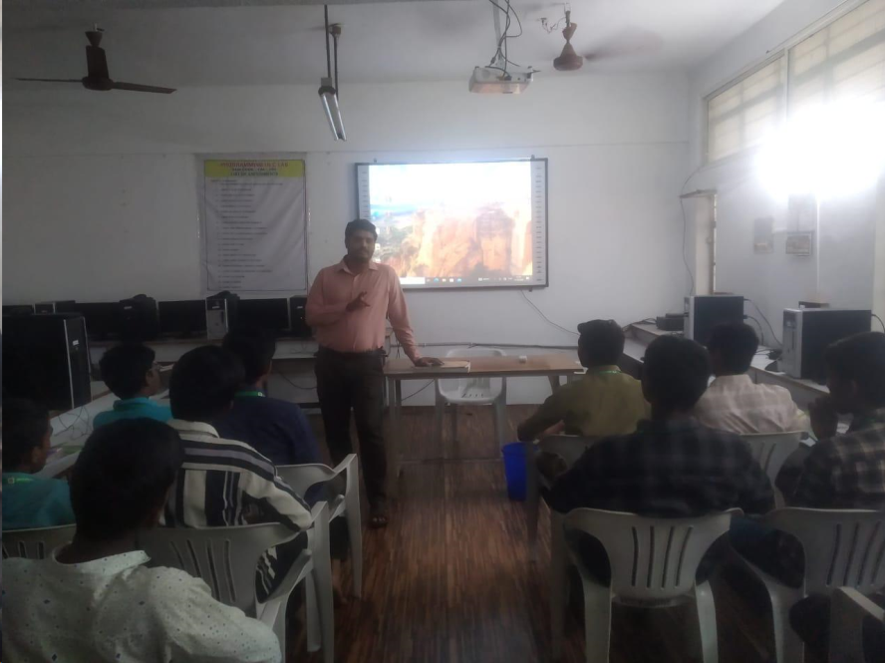

**ANNEXURE 4**

**Amateur Station Operator Certificate (ASOC) Exam 2024**

**Project Title:** Amateur Station Operator Certificate(ASOC) Exam conducted by HAM Radio Club.

**Organized by:**Department of Electronics and Communication Engineering, Vasavi College of EngineeringIn Association with Amateur Radio Digital Communications (ARDC)-USA

**Venue:**Vasavi College of Engineering,Ibrahimbagh, Hyderabad.

**Date:November 29th.**

**Introduction**

This exam is to get an Amateur Station Operator Certificate to operate HAM Radio Equipment installed in Vasavi College of Engineering. This exam also helps the students know the rules in operating HAM equipment. As part of the project implementation Amateur Station Operator Certificate (ASOC) Exam 2024 was organized by Ham Radio club in collaboration with NIAR, Hyderabad. This exam aimed to engage students in understanding importance, functionality and rules and regulations of amateur radio communications.

**Exam Overview**

Exam started at 12pm. A total of 44 people attended the exam in that:

* 4 attended for General And Restricted Grade
* 1 attended for general Grade
* 39 attended for Restricted Grade

The exam was held for 2 hours in the seminar hall

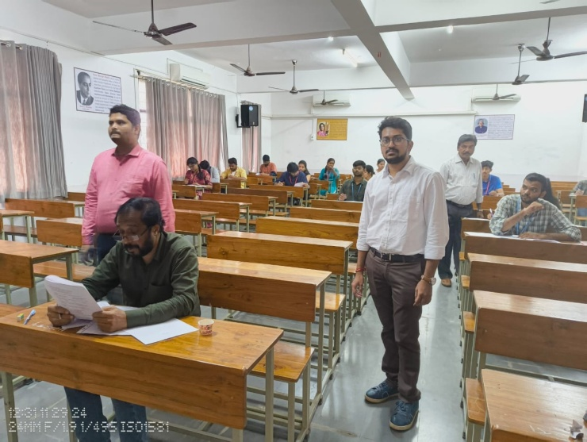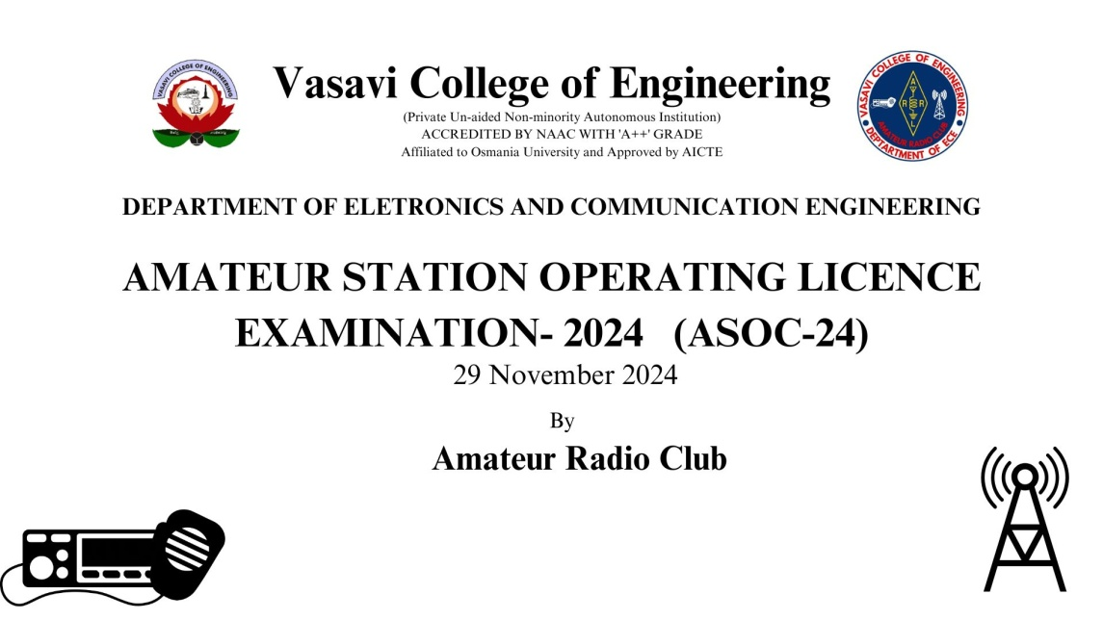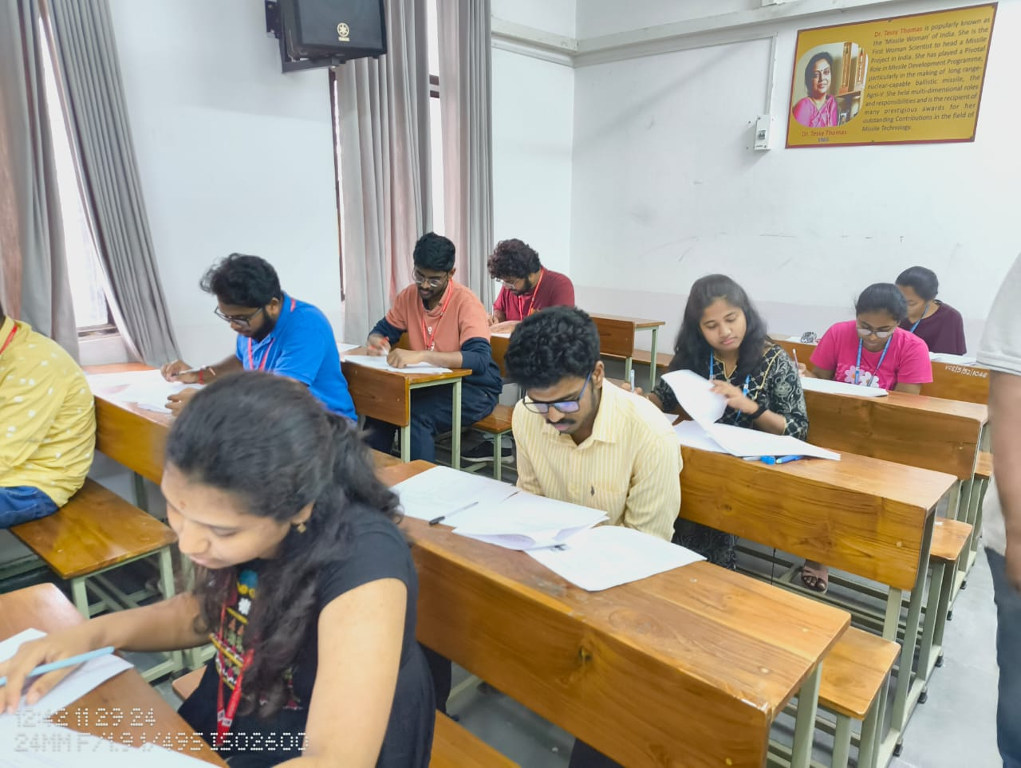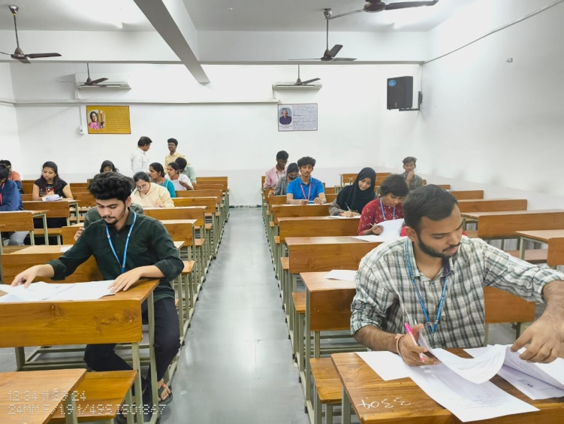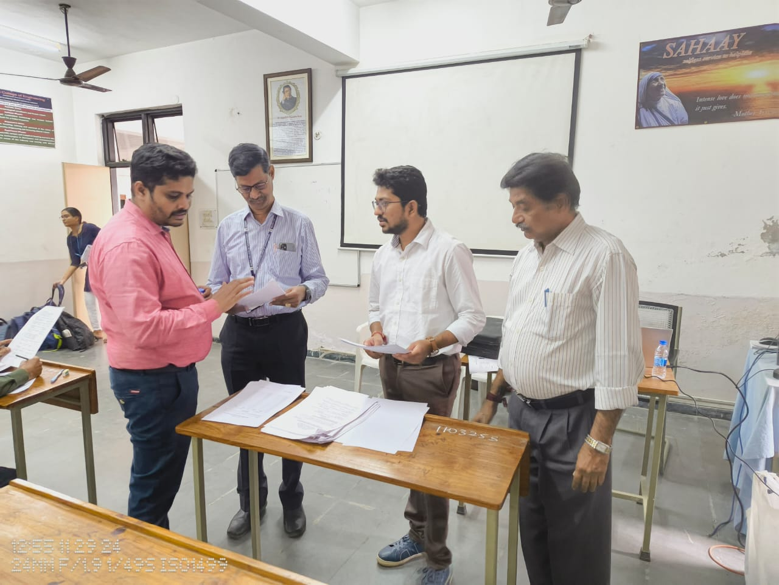

**ANNEXURE 5**

**ANTENNAS INSTALLATION**

**Project Title:** Antenna Installation at all three stations of Vasavi Educational Academy.

**Organized by:**Department of Electronics and Communication Engineering, Vasavi College of EngineeringIn Association with Amateur Radio Digital Communications (ARDC)-USA

**Venue:**Vasavi College of Engineering,Ibrahimbagh, Hyderabad.

**Date: December 31st ,2024.**

**Introduction**

This report details the successful installation of different antennas to establish and enhance the skill set of students in amateur (HAM) radio communication. The efforts are aimed at equipping students with hands-on knowledge and experience in analog and digital communication technologies, supported by newly established Amateur Radio Research Labs.

**Installation Overview**

The installation of antennas was taken out in two phases,where we successfully installed different types of antenna across various educational institutions:

* **Phase-1:**

Installation of VHF,UHF,HF antennas at Vasavi College of Engineering and at Vasavi Public School.

* **Phase-2:**

Installation of VHF,UHF,HF antennas at Vasavi Polytechnic College.

* **Phase-3:**

Installation of Hex beam antenna at Vasavi College of Engineering

**Antenna Installation**

**Phase-1:**

**Date : November 16,2024.**

We have installed **X-300**, **X-520M** antenna for VHF,UHF communication and **WD330** Diamond make antenna for HF communication in Vasavi College of Engineering,Hyderabad.

We have installed **X-520M** antenna for VHF,UHF communication and **WD330** Diamond make antenna for HF communication in Vasavi Public School,Hyderabad.

**Phase-2:**

**Date : December 28,2024.**

We have installed **X-520M** antenna for VHF,UHF communication and **HEX Beam**,**WD330** Diamond make antenna for HF communication at Vasavi Polytechnic College,Banaganapally,Kurnool.

**Phase-3:**

**Date: March 01,2025**

We have installed **HEXBEAM** antenna with G-450C rotator in Vasavi College of Engineering.

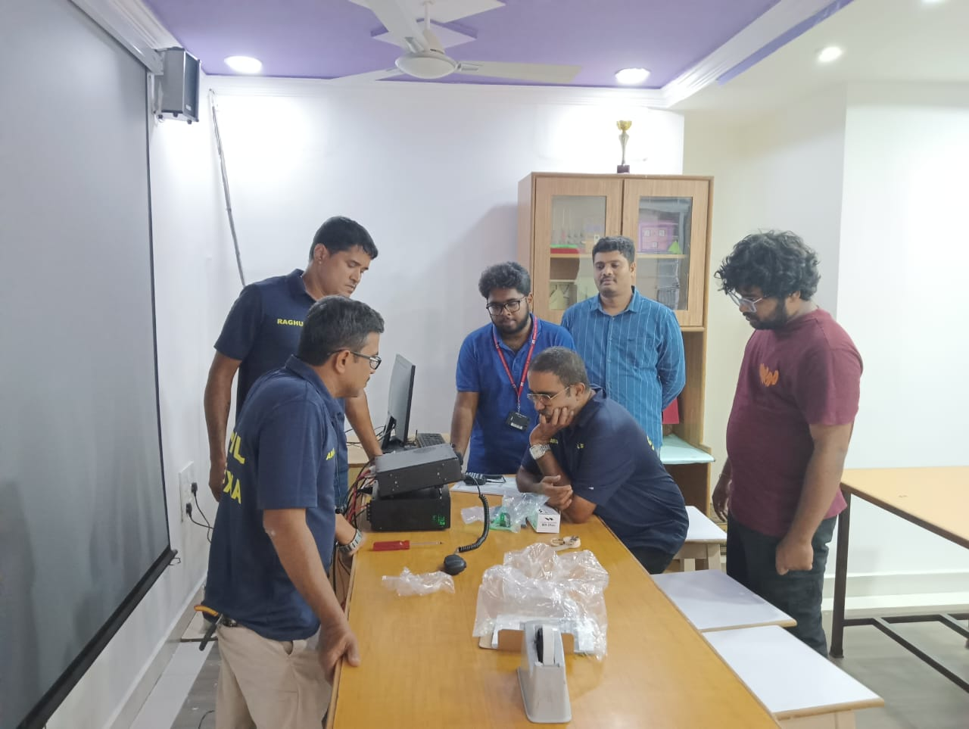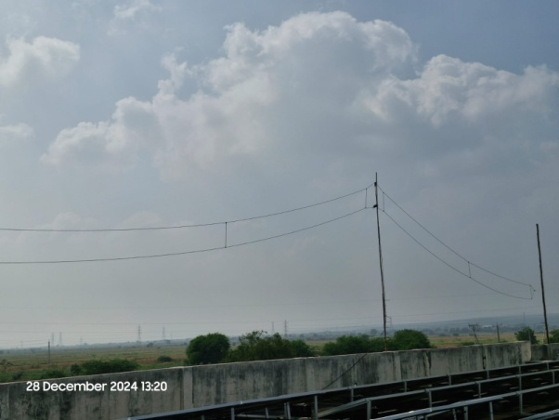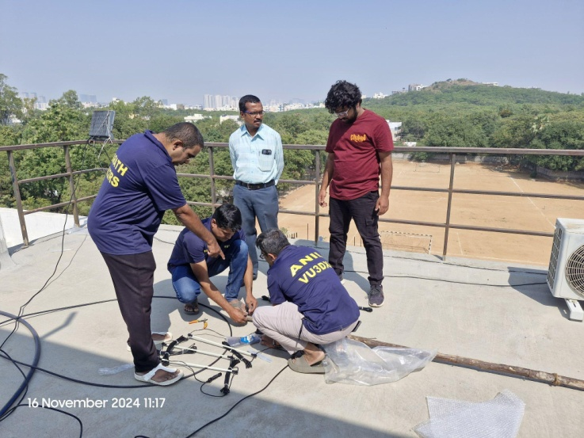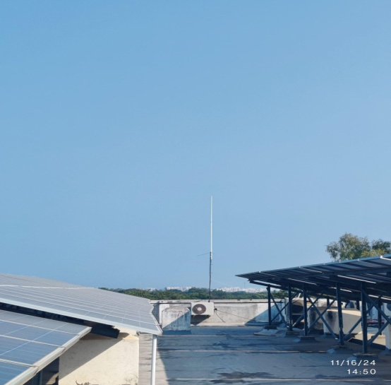

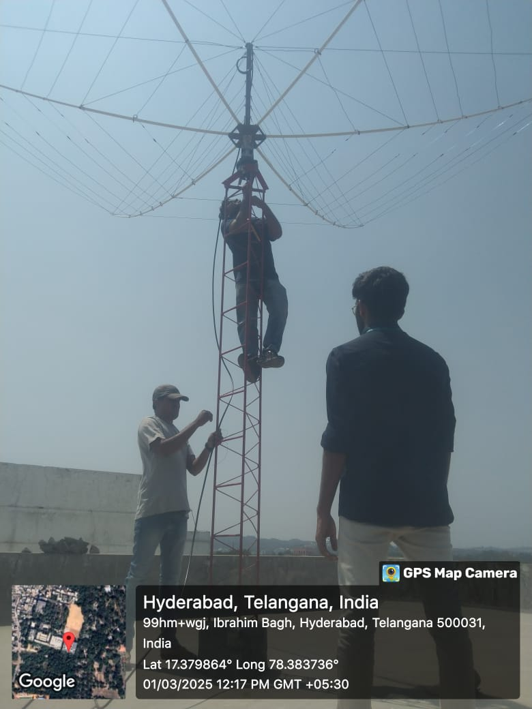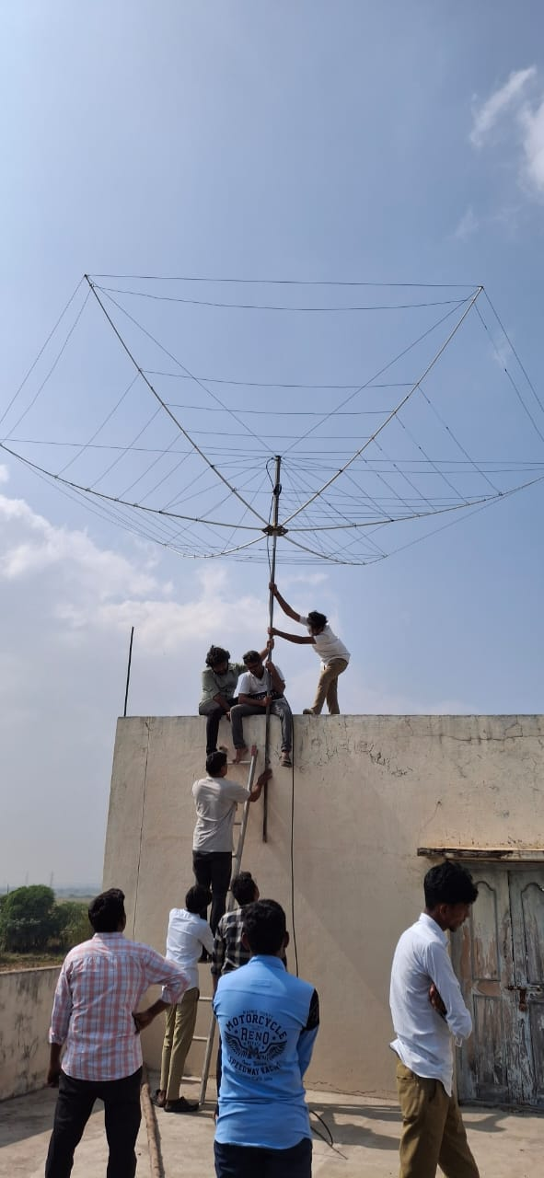

**ANNEXURE 6**

**Amateur Station Operator Certificate (ASOC) Exam 2025**

**Project Title:** Amateur Station Operator Certificate(ASOC) Exam conducted by HAM Radio Club.

**Organized by:**Department of Electronics and Communication Engineering, Vasavi College of EngineeringIn Association with Amateur Radio Digital Communications (ARDC)-USA

**Venue:**Vasavi Polytechnic College, Banaganapally, Kurnool.

**Date: January 9, 2025.**

**Introduction**

This exam is to get an Amateur Station Operator Certificate to operate HAM Radio Equipment installed in Vasavi Polytechnic College. This exam also helps the students know the rules in operating HAM equipment. As part of the project implementation Amateur Station Operator Certificate (ASOC) Exam 2025 was organized by Ham Radio club in collaboration with WPC, Vijaywada. This exam aimed to engage students in understanding importance, functionality and rules and regulations of amateur radio communications.

**Exam Overview**

The exam started at 12pm. A total of 80 people attended the exam in that:

* All 80 attended for Restricted Grade

The exam was held for 1 hour in the classroom at Vasavi Polytechnic College.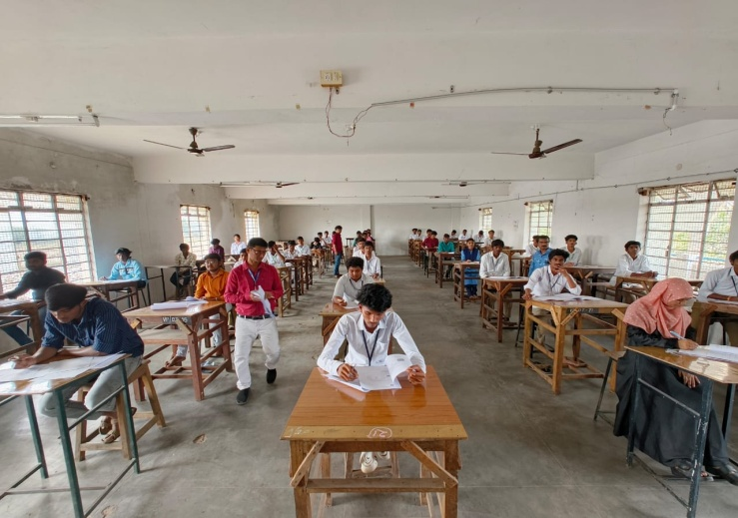

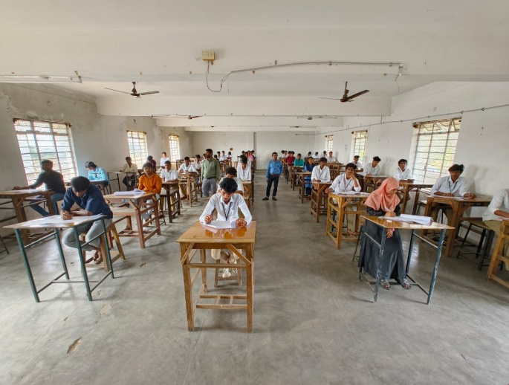

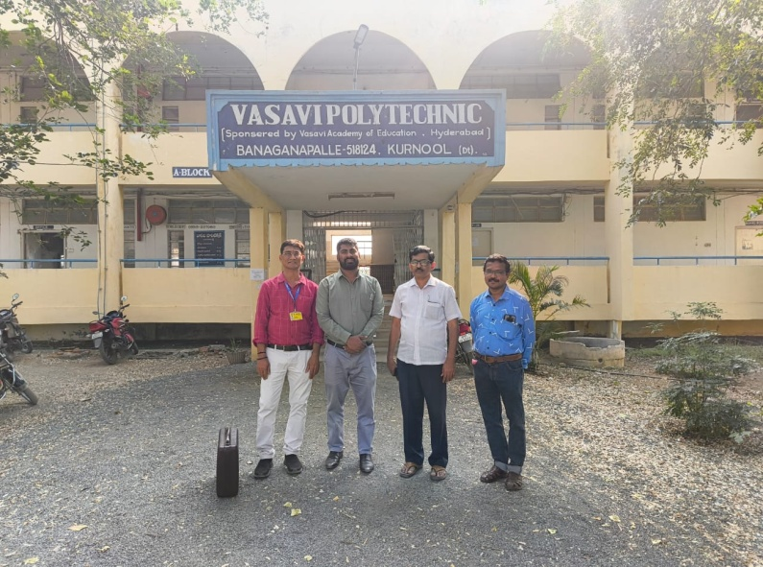

**ANNEXURE 7**

Amateur Station Operator Certificate (ASOC) Exam 2025

**Project Title:** Amateur Station Operator Certificate(ASOC) Exam conducted by HAM Radio Club.

**Organized by:**Department of Electronics and Communication Engineering, Vasavi College of EngineeringIn Association with Amateur Radio Digital Communications (ARDC)-USA

**Venue:**Vasavi College of Engineering,Ibrahimbagh, Hyderabad.

**Date: February 13,2025**

This exam is to get an Amateur Station Operator Certificate to operate HAM Radio Equipment installed in Vasavi College of Engineering. This exam also helps the students know the rules in operating HAM equipment. As part of the project implementation Amateur Station Operator Certificate (ASOC) Exam 2025 was organized by Ham Radio club in collaboration with NIAR, Hyderabad. This exam aimed to engage students in understanding importance, functionality and rules and regulations of amateur radio communications.

# Exam Overview

Exam started at 11am. A total of 65 people attended the exam in that:

● 3 attended for General And Restricted Grade

● 2 attended for general Grade

● 60 attended for Restricted Grade

The exam was held for 2 hours in the seminar hall

